Cost-based optimizer

Lab 2- The EXPLAIN ANALYZE command

Estimated completion time
- 20 minutes

Learning objectives
- In this lesson, you will build upon your knowledge of query plans by examining the output of the SQL EXPLAIN ANALYZE command. You will once again compare the query plan output for a relational database and a data lake.

Activities
- Understanding EXPLAIN ANALYZE
- Set up relational database environment
- Run the EXPLAIN ANALYZE command for a query in MySQL
- Review plan Fragment 2
- Review plan Fragment 1
- Run EXPLAIN ANALYZE on a data lake
- Set up your data lake environment
- Run EXPLAIN ANALYZE for the query from the first section
- Review plan Fragment 2

Step 1 - Understanding EXPLAIN ANALYZE
EXPLAIN ANALYZE differs from EXPLAIN in that it not only provides the query plan but executes the query as well. You will see some additional information in the query plan output.

It includes the extra execution metrics that illustrate what occurred when the SQL ran.

It does not include a Fragment 0 because the result of an EXPLAIN ANALYZE is the plan itself. This is because the system does not output the results of the SQL, which nullifies the need for a Fragment 0.

Step 2 - Set up relational database environment
Begin by setting up your environment using the following steps:
- Sign in to your Starburst Galaxy account.
- Expand Query and click Query editor.
- Set the cluster to query-plan-labs.
- Set the catalog to mysql_query_plan.
- Set the schema to query_plan_without_stats.

Step 3 - Run the EXPLAIN ANALYZE command for a query in MySQL
Notice that the query is the same one you used in the last lesson.

EXPLAIN ANALYZE
SELECT c.mktsegment, COUNT(*)
FROM customer c
WHERE c.acctbal > 1000
GROUP BY c.mktsegment;

Step 4 - Review plan Fragment 2
Review the labeled graphic of Fragment 2 below. Click on each plus sign to learn more about the corresponding section of the fragment.

Note: Don't forget to read from the bottom up.

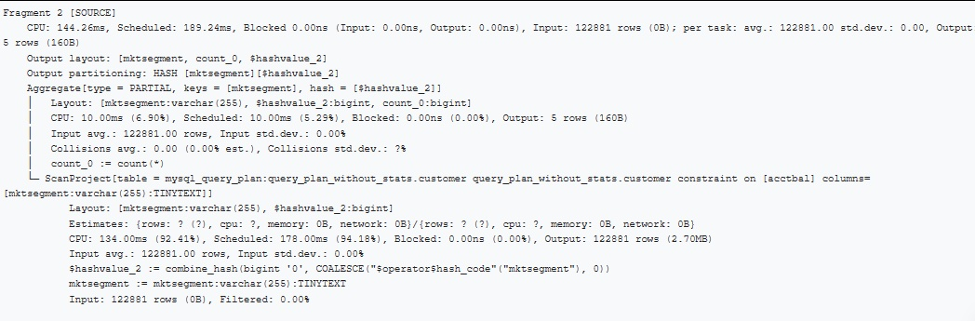

Click here to explore the query plan fragment.

Step 5 - Review plan Fragment 1
Notice that the final aggregation of the hashes is a very small part of the overall processing time.

You should see the same additional information as in Fragment 2.
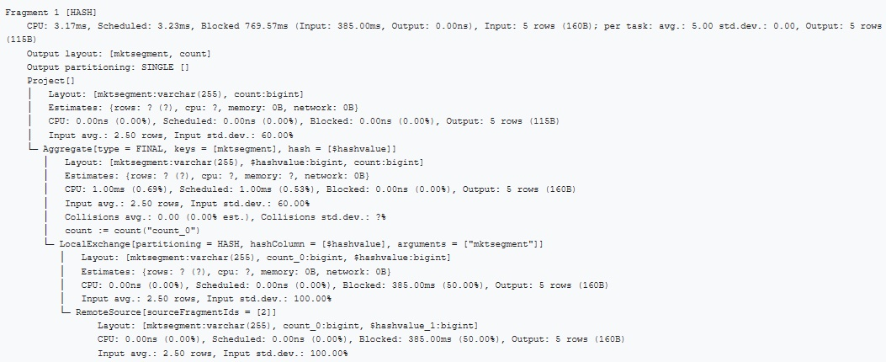

Step 6 - Run EXPLAIN ANALYZE on a data lake
In this section, you’ll run EXPLAIN ANALYZE on the same query that you ran in the last section. This time, however, you will be querying a data lake rather than a relational database. The explanations provided will focus on the differences between hive and what you saw with MySQL.

Step 7 - Set up your data lake environment
Begin by setting up your environment using the following steps:
- Open another browser tab and log in to your Starburst Galaxy account
- Expand Query and click Query editor.
- Set the cluster to query-plan-labs.
- Set the catalog to lakehouse_query_plan.
- Set the schema to query_plan_without_stats.

Step 8 - Run EXPLAIN ANALYZE for the query from the first section
Run the following SQL:

EXPLAIN ANALYZE
SELECT c.mktsegment, COUNT(*)
FROM customer c
WHERE c.acctbal > 1000
GROUP BY c.mktsegment;

Step 9 - Review plan Fragment 2
There are several interesting differences between the EXPLAIN ANALYZE running on MySQL and Hive.

Review the labeled graphic of Fragment 2 below. Click on each plus sign to learn more about the corresponding section of the fragment.

Note: Don't forget to read from the bottom up.

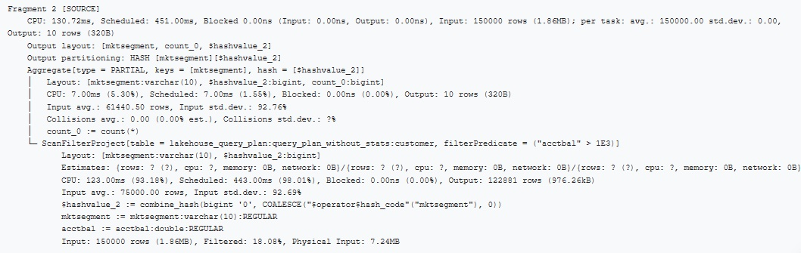

Click here to explore the query plan fragment.

END OF LAB EXERCISE

